from the depths of underhell they rose up to sweep away the pop-dirt in the dancehalls.
emo-pussies & hardcore thugz can take a shit. if you like to burn churches and some coppers for dessert, don't miss this!
what can you expect? a rash, overdosed rose hip tea and a blend of punk, metal and ska beyond good and p.c..

dancehall satan exist since summer04 and they played various shows with i.e. leftover crack.
this spring they did a greek tour with their labelmates from welcome to the last millennium and the greek heroes from vodka juniors and for what is worth.
some of the members used to play in infinite justice, the pioneers of the satanic trash-ska sound.

location: tha ostalb (about 1h east of stuttgart)
label: trash compost records
sound: satanic trash-ska

memberz:  loki - drums  longiz - guitar  rev 666 - bass & vocals  lord shizak - guitar & vocals  contact:  daniel langer  marienbaderstr. 3  73540 heubach  e-mail: longiz@gmx.net  phone: +49 7173 913661  mobile: +49 173 6577110  www.dancehallsatan.com | 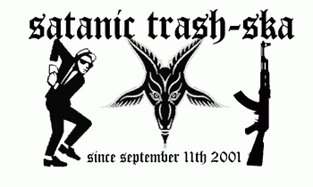  www.satanictrashska.com

